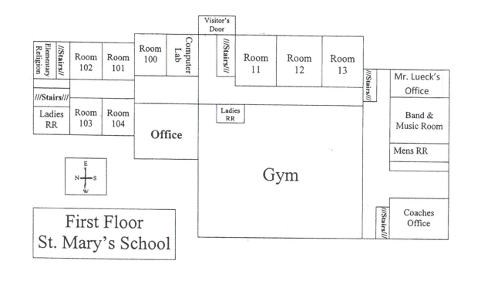

Mrs. Strom’s

Office

**Seneca Street**

**2nd Street**