Kilo-  ***** | Hecto- | Deka- | ***** | Deci-  ***** | Centi-  ***** | Milli-  *****
1000 | 100 | 10 | Meter | 0.1 | 0.01 | 0.001
 |  |  | Liter
 |  |  | Gram
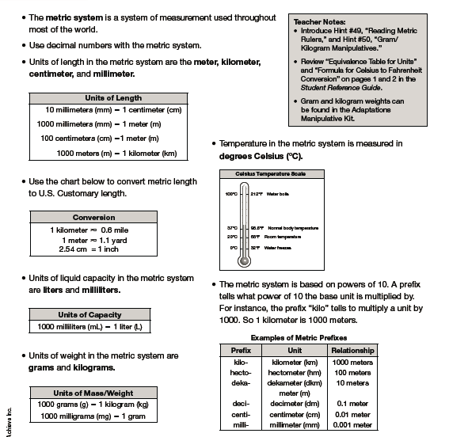
Lesson 32 – Metric System Charts

