MATH REFERENCE CARD - 2016-17
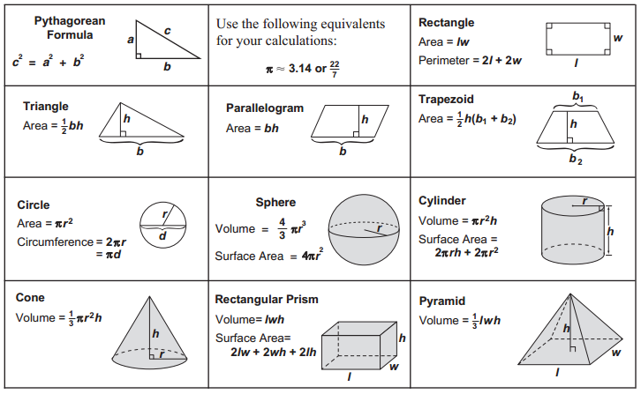

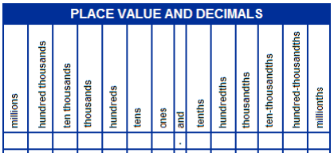
Conversions

12 inches = 1 foot 60 seconds = 1 minute
3 feet = 36 inches = 1 yard 60 minutes = 1 hour
1,760 yards = 5,280 feet = 1 mile 24 hours = 1 day
1 acre = 43,560 square feet 7 days = 1 week
365 days = 1 year

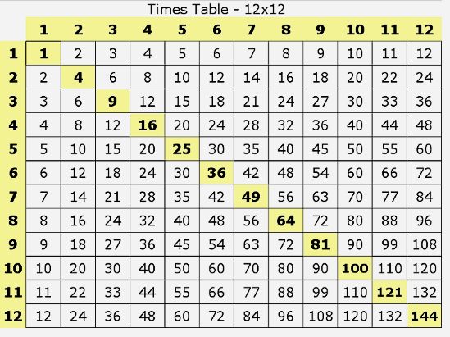
10 millimeters = 1 centimeter 1 pound = 16 ounces
10 decimeters = 1 meter 1 ton = 2,000 pounds
100 centimeters = 1 meter
1000 meters = 1 kilometer 1000 milliliters = 1 liter
1 liter = 1000 cubic cm

1 cup = 8 fluid ounces 1 gram = 1000 mg
1 pint = 2 cups 1 kilogram = 1000 g
1 quart = 2 pints
1 gallon = 4 quarts

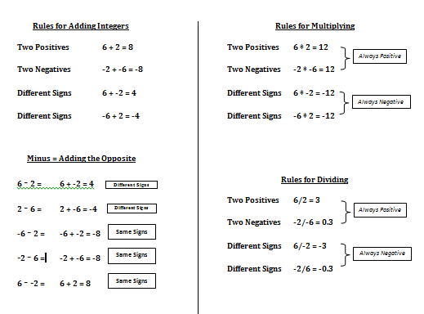
MATH REFERENCE CARD - 2016-17

