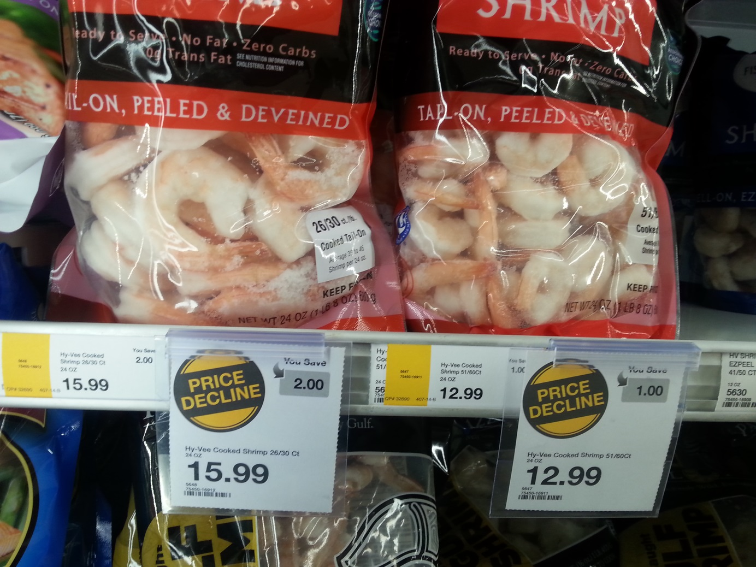
Carefully read through these 2 package descriptions and the price tags.
Can you justify why they have different prices?

