Dear Sophomore Parents, (Class of 2019)
I would like to let you know that I am the Sophomore class moderator, and this will be a big year for fundraising. Most of the money they will need for future events, such as; prom, homecoming and graduation will be raised this year. By the time prom rolls around they should hope to have almost $5000. There will be only one fundraiser their junior year to help with that amount, (t-shirt sales).
We have been given a great fundraiser to work on. It has helped the past four classes raise about $1000 - $1200 each. It is collecting empty ink/toner cartridges and used electronics from businesses and private individuals around town and then sending them in for refund money. It has been a wonderful surprise to see how many cartridges there are to collect and how grateful the businesses are to have someone to count on for this service.
My intention is for the students to take ownership of this fundraiser as much as possible, but they will need some adult supervision on packing day and possibly a family member to transport them around Storm Lake to various businesses while they collect. You will find an attached schedule. When it is your child’s month they will be responsible for picking up the cartridges and packaging them for shipping along with the rest of the group. An adult has to be with students when packaging, so please contact me as soon as possible with the date your group has decided to package and who will be there. I typically try to be free to help and to show them the ropes.
If you know of other businesses that might be interested in being added to the collection please let me know. I would like to make contact with them before we add them to our route. The class will be handing out posters and flyers for the businesses to show their customers and employees what type of items we collect. It will also be put into the monthly newsletter and website and it will be sent out in the students Panther Packs. I am hoping to also get some article in the newspapers. Please share with as many people as you can.
Please look through the schedule and find where your son/daughter has been assigned. If you have a conflict, please try to find a replacement ahead of time. I also need to have the Agreement Form signed and returned to me by Sept. 30th. The class has decided that if a student does not complete their work for their assigned month they will be fined $50, to be put in the class fund. Hopefully there will be no need to enforce this fine. If you have any questions please feel free to call me at the school, email me or you can reach me on my cell phone.
Thanks for your support,
Mrs. Angie Siefken
Email: asiefken@stormlakecatholic.com
School phone: 712-732-4166
Cell: 712-660-3941
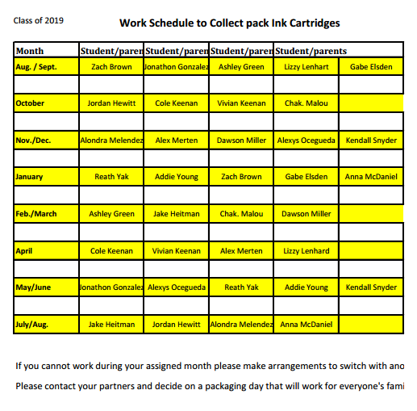
Please cut along dotted line and return to school.

Parent Agreement Form

I have read the letter above and agree to have my son/daughter participate in the Sophomore fundraiser of collecting Ink Cartridges.

Parent Signature ___________________________ Date _____________
